CS 300 HOMEWORK 5

Q1)

Step 1 Step 2 Step 3

|  |  |  |
| --- | --- | --- |
|  | Weight | Known |
| A | infinity | False |
| B | infinity | False |
| C | 2 | False |
| D | infinity | False |
| E | infinity | False |
| F | infinity | False |
| G | 0 | True |
| H | 2 | False |

|  |  |  |
| --- | --- | --- |
|  | Weight | Known |
| A | Infinity | False |
| B | 6 | False |
| C | 2 | True |
| D | infinity | False |
| E | infinity | False |
| F | 8 | False |
| G | 0 | True |
| H | 2 | False |

|  |  |  |
| --- | --- | --- |
|  | Weight | Known |
| A | 6 | False |
| B | 6 | False |
| C | 2 | True |
| D | infinity | False |
| E | infinity | False |
| F | 8 | False |
| G | 0 | True |
| H | 2 | True |

|  |  |  |
| --- | --- | --- |
|  | Weight | Known |
| A | 6 | True |
| B | 6 | False |
| C | 2 | True |
| D | infinity | False |
| E | 15 | False |
| F | 8 | False |
| G | 0 | True |
| H | 2 | True |

|  |  |  |
| --- | --- | --- |
|  | Weight | Known |
| A | 6 | True |
| B | 6 | True |
| C | 2 | True |
| D | infinity | False |
| E | 7 | False |
| F | 8 | False |
| G | 0 | True |
| H | 2 | True |

Step 6 Step 5 Step 4

|  |  |  |
| --- | --- | --- |
|  | Weight | Known |
| A | 6 | True |
| B | 6 | True |
| C | 2 | True |
| D | 10 | False |
| E | 7 | True |
| F | 8 | False |
| G | 0 | True |
| H | 2 | True |

Step 7 Step 8

|  |  |  |
| --- | --- | --- |
|  | Weight | Known |
| A | 6 | True |
| B | 6 | True |
| C | 2 | True |
| D | 10 | False |
| E | 7 | True |
| F | 8 | True |
| G | 0 | True |
| H | 2 | True |

|  |  |  |
| --- | --- | --- |
|  | Weight | Known |
| A | 6 | True |
| B | 6 | True |
| C | 2 | True |
| D | 10 | True |
| E | 7 | True |
| F | 8 | True |
| G | 0 | True |
| H | 2 | True |

Q2)

Selected vertices and edges are shown in red for every step.

Step 1 Step 2

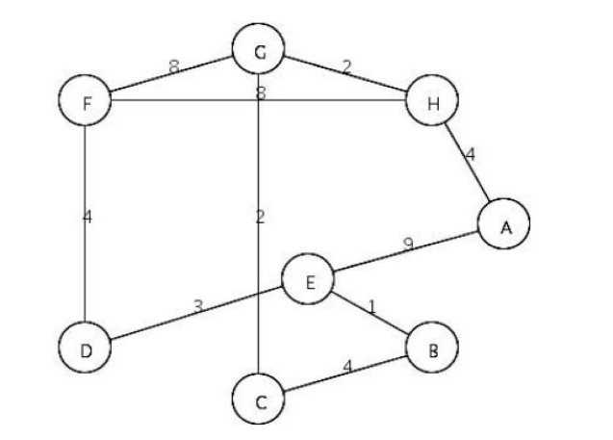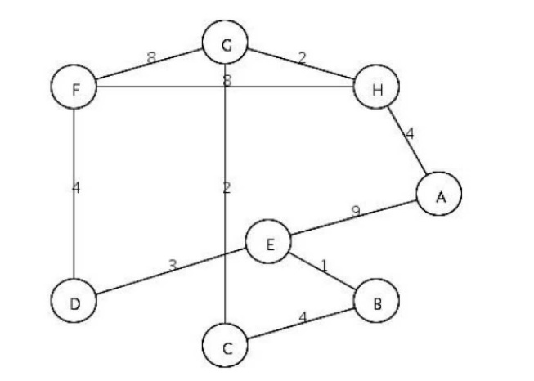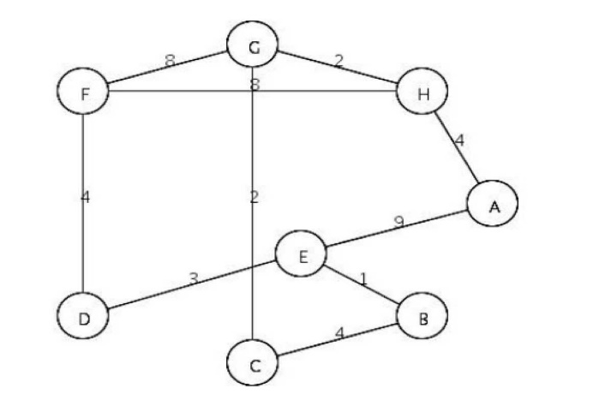

Q3)

The selected edges are shown in red at every step of the program.

Step 1 Step 2

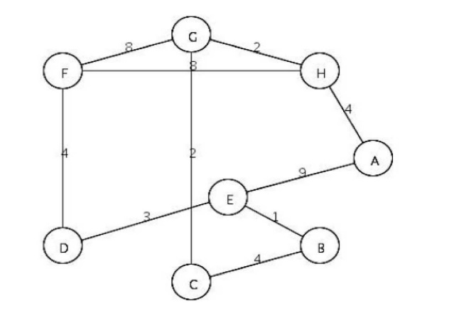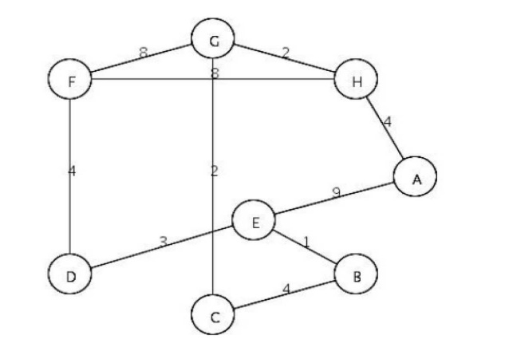

Step 3 Step 4



Step 6 Step 7



Step 8



Q4)

Step 1: Queue: S

Step 2: Queue: ~~S~~ – B – A – D

Step 3: Queue: ~~S~~ – ~~B~~ – A – D (We can not add new vertex to the queue since there is no adjacent vertex that is unknown)

Step 4: Queue: ~~S~~ – ~~B~~ – ~~A~~ – D – C

Step 5: Queue: ~~S~~ – ~~B~~ – ~~A~~ – ~~D~~ – C – E – T – F

Step 6: Queue: ~~S~~ – ~~B~~ – ~~A~~ – ~~D~~ – ~~C~~ – E – T – F

Step 7: Queue: ~~S~~ – ~~B~~ – ~~A~~ – ~~D~~ – ~~C~~ – ~~E~~ – T – F – G

Step 8: Queue: ~~S~~ – ~~B~~ – ~~A~~ – ~~D~~ – ~~C~~ – ~~E~~ – ~~T~~ – F – G

Step 9: Queue: ~~S~~ – ~~B~~ – ~~A~~ – ~~D~~ – ~~C~~ – ~~E~~ – ~~T~~ – ~~F~~ – G

Step 10: Queue: ~~S~~ – ~~B~~ – ~~A~~ – ~~D~~ – ~~C~~ – ~~E~~ – ~~T~~ – ~~F~~ – ~~G~~

Our breadth first search terminates until the queue is empty.

If I print the vertices after I dequeue it from the queue, the output will be below.

Output: S – B – A – D – C – E—T – F – G

Q5)

|  |
| --- |
| S |

1. Step 1: Stack:

|  |
| --- |
| B |
| S |

Step 2: Stack:

|  |
| --- |
| D |
| B |
| S |

Step 3: Stack

|  |
| --- |
| E |
| D |
| B |
| S |

Step 4: Stack:

|  |
| --- |
| G |
| E |
| D |
| B |
| S |

Step 5: Stack:

|  |
| --- |
| T |
| G |
| E |
| D |
| B |
| S |

Step 6: Stack:

|  |
| --- |
| F |
| T |
| G |
| E |
| D |
| B |
| S |

Step 7: Stack:

|  |
| --- |
| T |
| G |
| E |
| D |
| B |
| S |

Step 8: Stack:

|  |
| --- |
| G |
| E |
| D |
| B |
| S |

Step 9: Stack:

|  |
| --- |
| E |
| D |
| B |
| S |

Step 10: Stack:

|  |
| --- |
| D |
| B |
| S |

Step 11: Stack:

|  |
| --- |
| B |
| S |

Step 12: Stack:

|  |
| --- |
| S |

Step 13: Stack:

|  |
| --- |
| A |
| S |

Step 14: Stack:

|  |
| --- |
| C |
| A |
| S |

Step 15: Stack:

|  |
| --- |
| A |
| S |

Step 16: Stack:

|  |
| --- |
| S |

Step 17: Stack:

Our DFS terminate when there is no element in the stack.

Output: S – B – D – E – G – T – F – A – C (If I print the vertices that I visit that are unknown).

1. Post Orders:

S: 9

B: 6

A: 8

D: 5

C: 7

E: 4

G: 3

T: 2

F: 1

1. Pre Orders:

S: 1

B: 2

A: 8

D: 3

C: 9

E: 4

G: 5

T: 6

F: 7

d)

Tree arcs: (S, B), (B, D), (D, E), (E, G), (G, T), (T, F), (S, A), (A, C)

Forward arcs: (S, D), (D, T), (D, F),

Backward arcs: (B, S), (G, E)

Cross arcs: (C, E), (E, T), (C, D)

Q6) Since the vertex A and G are degree 0, I enqueue them in to the queue(I picked the first one arbitrarily), after that, when I dequeue the vertex from the queue, I looked the adjacent vertices of that vertex and if the vertex’s indegree is zero when I decrement the indegree of that vertex by one I add it to the queue.

A – G – B – D – C – E – F

Efe Şencan 25083